**Build Your Own Computer**

**HW #2**

I.D 201322708 Tal Kain

I.D. 300267390 Idan Ben-Zvi

I.D. 204200026 Michal Momika

3.1. The Test Bench 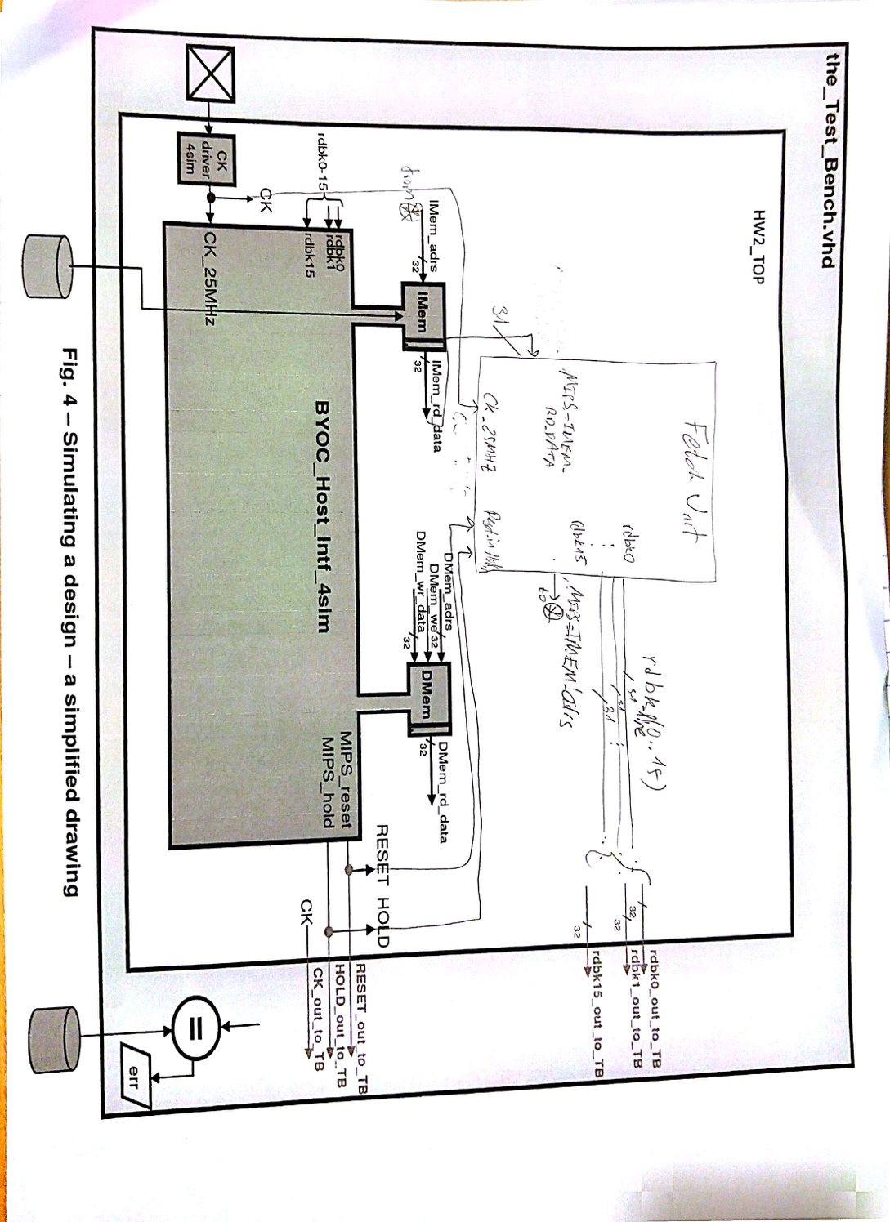

**3.2.** Simulation Screenshots

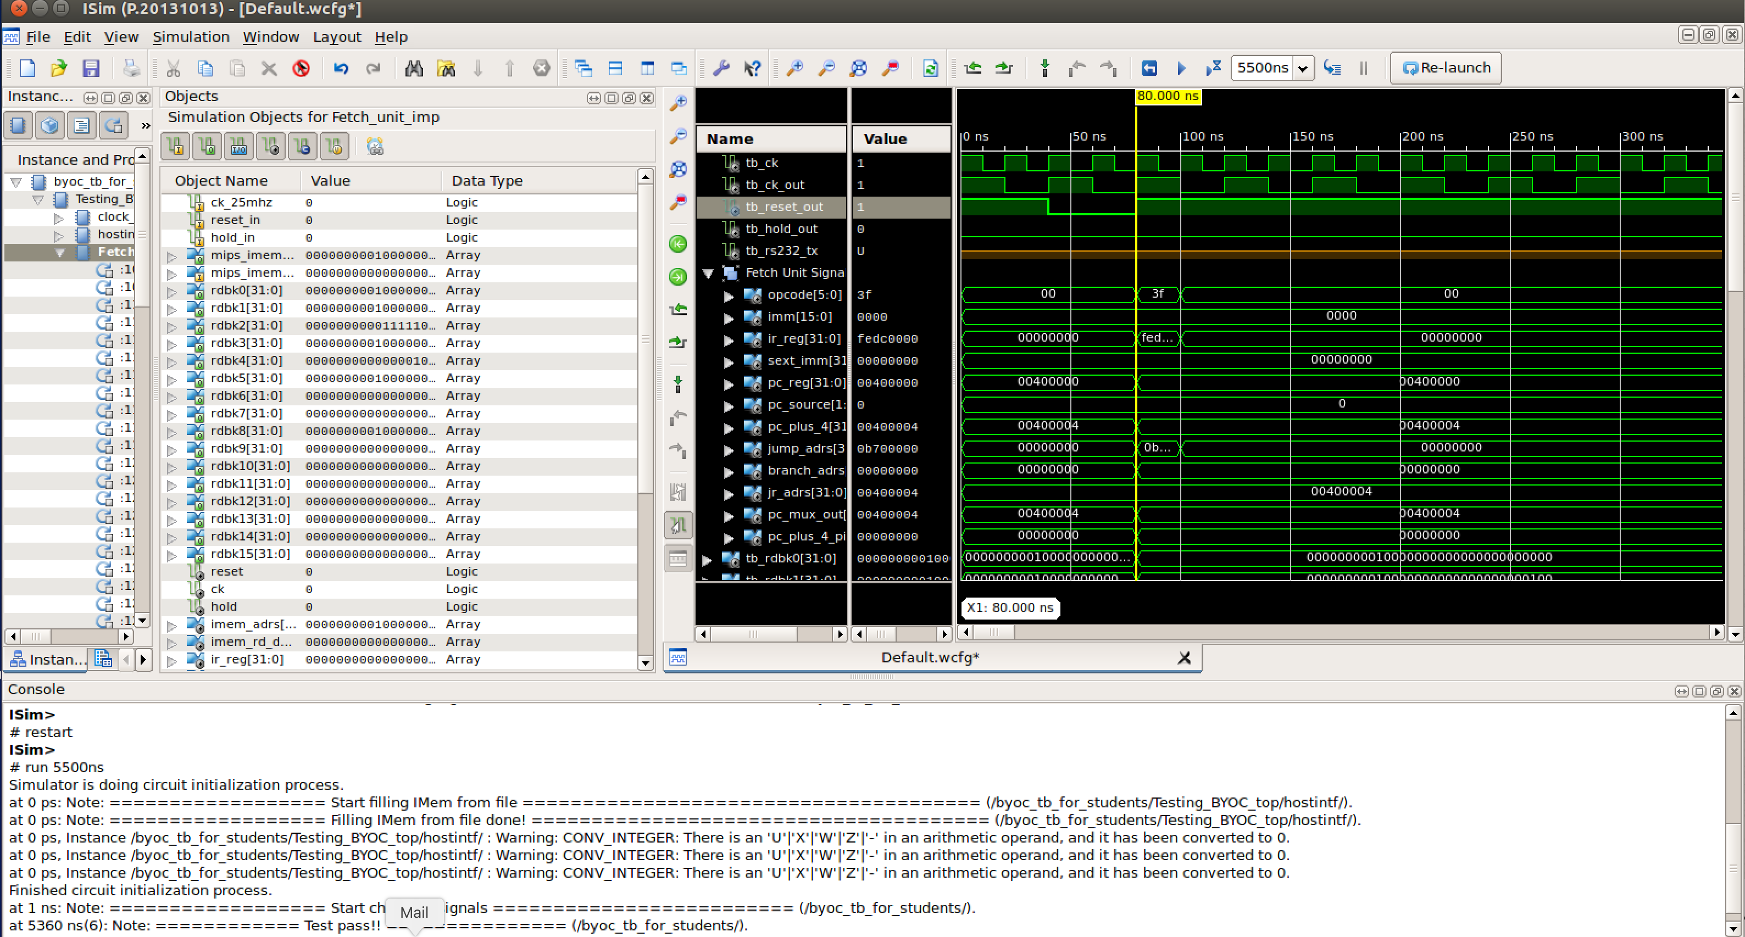

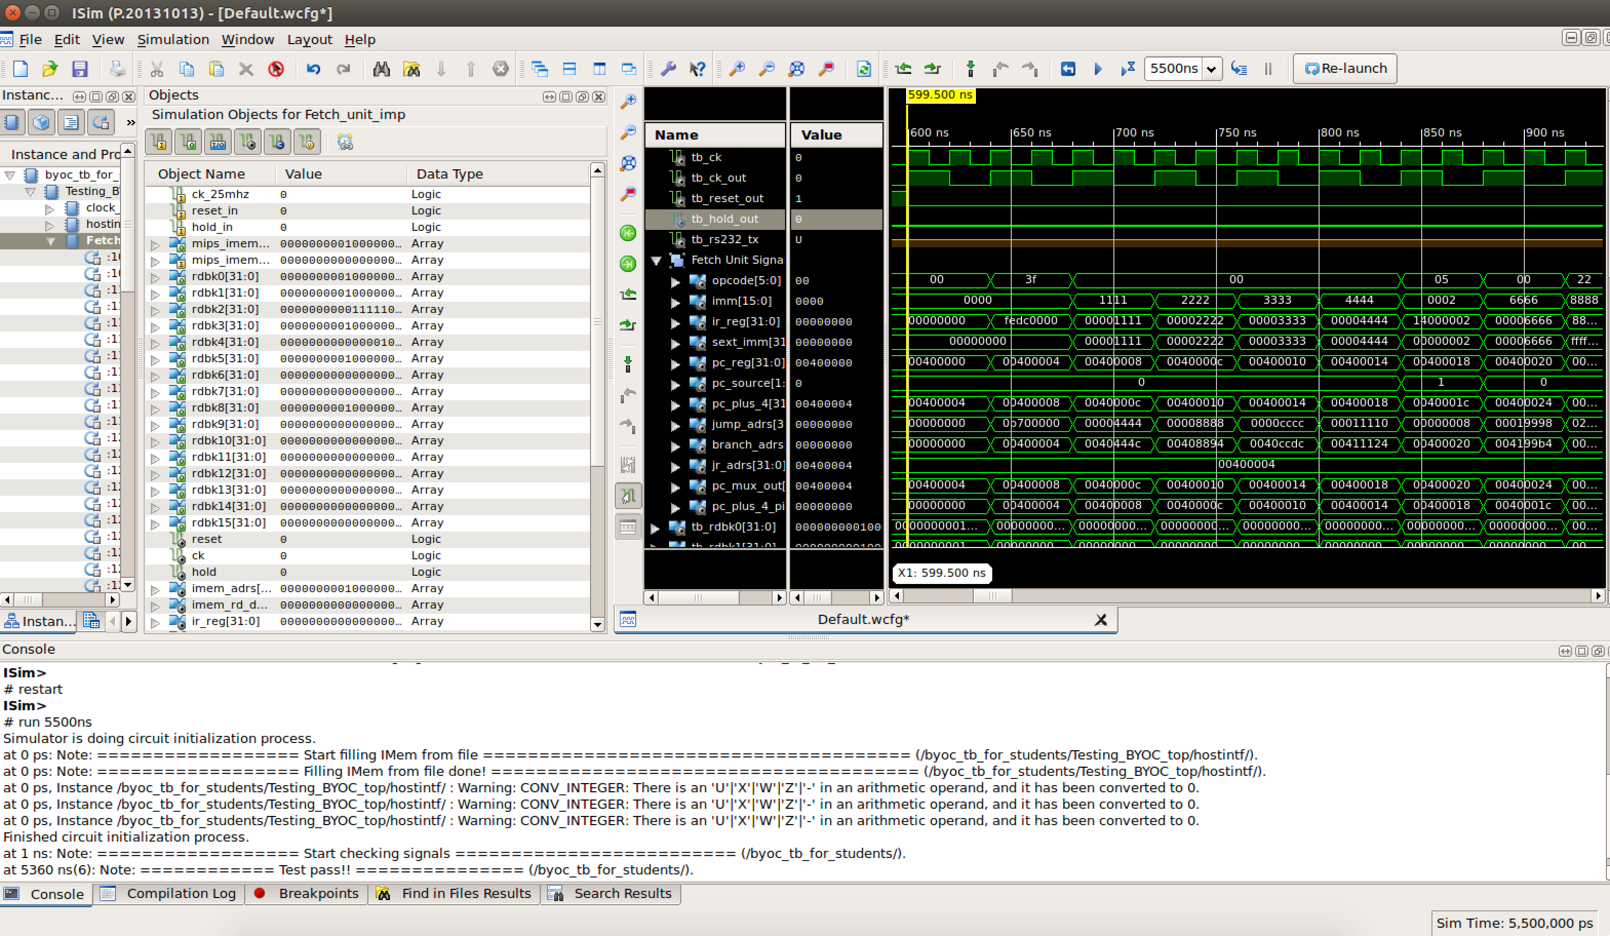

**3.3.**

PC_plus_4_pID <= Adr+4

The previous address was loaded to the IMem and the next instruction address is increased by 4 and saved into PC_plus_4_pID

PC_Reg <= We cannot be sure what will be the value of PC_Reg since it depends on the PC_Source_mux, and it depends on the previous instruction, for instance, PC_Source = ‘11’, which means the value of PC_Reg will be x”00400004”

3.4.  
**Hex: 0x14000002 as translated to MIPS instruction**

|  |  |  |  |  |  |  |  |
| --- | --- | --- | --- | --- | --- | --- | --- |
| 31 | 26 | 25 | 21 | 20 | 16 | 15 | 0 |
| BNE | | $zero | | $zero | | offset | |
| 000101 | | 00000 | | 00000 | | 0000000000000010 | |
| 6 | | 5 | | 5 | | 16 | |

This instruction describes a condition that will never be true, as $0 is compared to $0 (0 to 0), a jump will not be performed. The comparison is done in the ALU unit.

3.5

When performing the branch instruction in address x"00400014" (“0x14000002”) we were not supposed to branch according to the comparison in section 3.4. However, a branch did occur and we did not execute the command in 0x0040001c.

The following instructions were executed:  
x"00400008" => x"00002222"

x"0040000C" => x"00003333"

x"00400010" => x"00004444"

x"00400014" => x"14000002" -- bne 2 instructions forward, jump  to 0x40020

x"00400018" => x"00006666"

x"00400020" => x"88888888"

x"00400024" => x"00009999"

x"00400028" => x"0000AAAA"

Implementation Report

During the execution of the stored program from the .dat file, we saw that an error occurred when comparing the data in the registers to the comparison file on the first command. This error occurred since the first command was incorrectly typed in the .dat file (in 0x0040000 – “0xFEDC0067” instead of “0xFEDC0000”).   
When the command was fixed, by changing the .dat file and reloading the program to the board – no additional errors occurred.